Modified DACUM Research Chart  Diversified Occupations- Entry-Level Worker  CIP 32.0105 Job-Seeking/Job-Changing Skills  DACUM Panel  Representing 183 years of experience in hiring/managing employees  Tami Case, Human Resources Manager, EnTech Plastics, Inc.  Corry, PA  Rob Eggleston, D.O. Instructor, Erie County Technical School  Erie, PA  Michelle Eriksen, Office Manager/Safety Coordinator, VIP Machining, Inc. and Accounts Payable/Receivable - Burke Forging and Heat Treating, Inc., Corry, PA  Brody Howard, Executive Director, Corry Higher Education Council, Corry, PA  Eric Louis, Principal, Girard High School  Girard, PA  Paula Merkle, Personnel Administrator, Corry Manufacturing, Corry, PA  Antonella Spinelli, Business Education Teacher/Career Development Facilitator, Girard School District, Girard, PA  Jean Volk, Office Manager, Corry Federal Credit Union, Corry, PA  Observers and Facilitator  Susan Bogert, Supervisor of Vocational Education  Corry Career & Technical Education Center, Corry, PA  Mike Daniels, Cooperative Education Coordinator  Corry Career & Technical Education Center, Corry, PA  Jan Kennerknecht, DACUM Facilitator  Kennerknecht Consulting, Edinboro, PA |  | 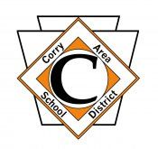  Sponsored by  Corry Area School District  Career & Technical Education Center  Produced by  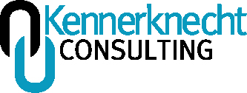  October 21, 2022

General Knowledge

Workplace safety
Math
Etiquette (workplace appropriate)
Company rules/policies/procedures
Dress code
Finances: money management/budget literacy
Taxes
Entry-level vs. career ladder
Driver’s license
Auto insurance
Company vision
How to use and where to find resources
Microsoft Word/Excel/PowerPoint
Inventory
Knowledge of how social media can affect their job

General Skills

Written/oral communication skills
Interpersonal skills
Problem solving skills
Telephone skills
Time management skills
Conflict resolution skills
Organizational skills
Social skills
Technical skills

Worker Behaviors

Tolerant
Shows initiative
Team player
Punctual
Good listener/attentive
Assertive
Positive attitude
Kind/respectful
Personable
Prompt
Dependable
Independent
Trainable/coachable
Follows company policy
Stays on task
Safe
Conscientious
Flexible/adaptive

Shows empathy
Accountable
Trustworthy
Has basic manners
Follows through

Current Trends in Employment

Flexible scheduling
Work location (more remote work)
Creative recruiting (including social media, staffing services, networking, offering bonuses, benefits to recruit employees- also used for retention)
A focus on retention, engaging employees
Employees are shopping, interviewing for higher paying jobs.
Employees know they are needed, they have leverage.
“Entitled” employees
COVID-19 pandemic has resulted in changing rules.
There is a skills gap, some positions are filled when employee does not have relative experience or certification. Employers are desperate to fill positions and will pay for training.
Clearances and proof of certifications are important, must be on file.
There is an extreme shortage of certified workers. Retired workers are being recruited.
Older employees are in the workforce. Trend toward recruiting the “hidden workforce”.
There is a large contingent of people from 18-22 who are not engaged yet in the workforce.
Cyber security is a current need. Phishing emails are more common, ransom ware is a concern.
Employers are reaching out to customers to find employees. (Creative recruiting)

Future Directions

The 16-17-year-old worker will want to be there, will want to earn a paycheck.
I foresee training for employees being paid wages as they are being trained, with training being paid for by employers. (Similar to mini-apprenticeship)
I see a swing of workers going back to the skilled trades. Competency building, quick-in/quick-out training, shifting of careers. Quick-start technical training, on-demand, high turnaround for high reward. Shorter investment.
There will be a hybrid of employees working from home and working at the employer’s place of business.
Productivity will improve.
Shorter work weeks (more hrs./day, longer weekend)
Free-lancing is on the rise.
Entrepreneurship spirit is on the rise.
Supply chain delays will affect employment.
The economy will affect employment.
Automation will affect employment.

Concerns

Lack of commitment in employees
Young employees are easily consumed with one perceived slight or crisis- drama kicks in.
Threat assessments for employees in mental health crisis- The pandemic has exacerbated anxiety issues.
The loss of skilled labor and product quality – need for hiring lower skill levels and training after hire. How much does process slow down because of mistakes? Re-working is required.
Material quality is going down, getting less for your money

The mentality of entitlement concerns employers. Lessons in empathy are needed.
Employees need to care about co-workers more and take pride in the company vision.
Employees need to separate personal life from workplace.
Drug use/abuse is a concern. Some prescribed drugs can also affect an employee’s safety and work production.
Employers are finding themselves working as a counselor.
Vaping use is affecting safety. Some employees have medical cards for legal vaping use. There is sometimes a disparity between state and federal rules. OSHA takes precedence. Company policies also take precedence.
Employees have a lack of want for personal enrichment, continual improvement, higher education.
Employers are concerned about the waste of resources for recruitment, the amount invested in interviewing. Ripple effects in HR will be “burn out”.
The pendulum or cyclical nature of employment in many industries (next five years), will result in a real bind for finding employees. This will significantly alter our way of life. There will be huge holes to fill.
Employees working from home are being passed up for promotion or training. Distractions at home are interfering with transfer of information.

Certifications Recommended

OSHA-10 Hour Safety Certification has value but employer will provide OSHA training annually.

General Recommendations for the Program

Consider purchasing a smart board or a large touch screen smart TV to engage students with interactive presentations. IFP7550-E1 75” View Board 4K HD Interactive flat panel bundle. ($2,126.91) OR CDE7520-W 75” 4K HD Panel Display ($1,953.19)

Investigate CTE 360 license for obtaining student work schedules and determine visiting route, time task sheets, pay slips, etc.- syncs with grade book. D.O. tasks could be entered also.

Consider using Zoom meetings to provide D.O. instruction at the workplace, reducing travel time for students.

Acronyms

Co-op Cooperative Education
D.O. Diversified Occupations
HR Human Resources
OSHA Occupational Safety and Health Administration

Advice for Students from DACUM Panel Members

Tami Case, Human Resources Manager, EnTech Plastics, Inc.: “Have a good attitude, enter the workforce with a good attitude.”

Rob Eggleston, DO Instructor, Erie County Technical School- “When you think no one is watching, everyone is watching. It’s not all about the money.”

Brody Howard, Executive Director, Corry Higher Education Council: “Be patient, there are a lot of opportunities that will allow for you to start at an entry-level. Advancement can happen much quicker than it has happened in the past- you will get there faster.”

Paula Merkle, Human Resources Administrator: “Don’t give up learning new things, the more you learn, the more valuable you will be.”

Michelle Eriksen, Office Manager/Safety Coordinator VIP Machining, Inc. and Accounts Payable/Receivable - Burke Forging and Heat Treating, Inc.: “Show responsibility, call in, show up, be prepared to do the job you are hired to do.”

Jean Volk, Manager, Corry Federal Credit Union, Office Manager: “Show up on time, be respectful, take the initiative to do things.”

Mike Daniels, Co-op Coordinator, Corry CTC: “Failure is never final. Success is a process, not a destination. Be resilient.”

Eric Louis, Principal, Girard HS: “Call in if you will be absent, follow through. Take personal responsibility, pride in yourself and the team you are working with. Your role as an employee is to support the industry. These are great lessons for later in life.”

Antonella Spinelli, Girard School District, Business Education Teacher/Career Development Facilitator: “Network with everyone you meet. You never know who might be your next boss, who might have connections to help you get to higher places.”

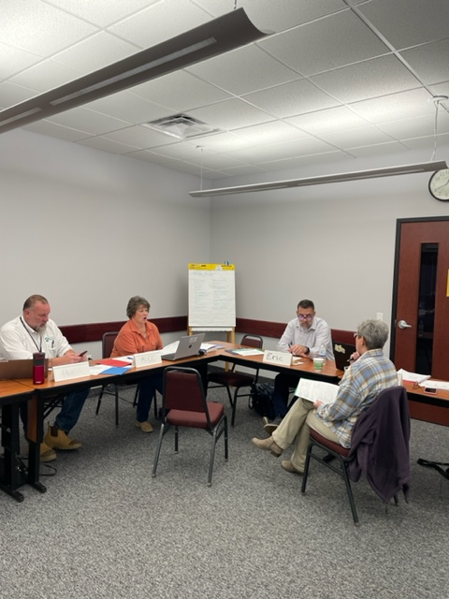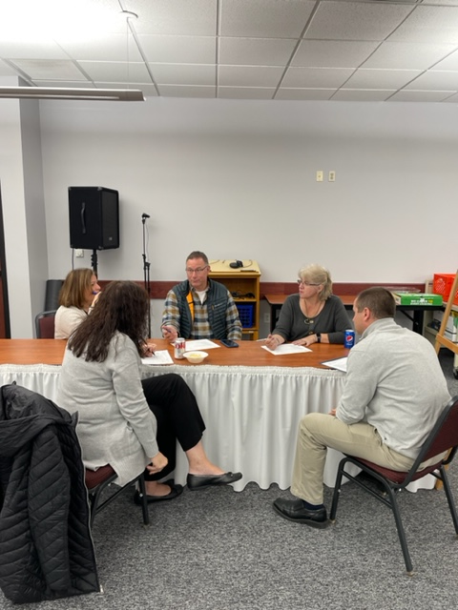

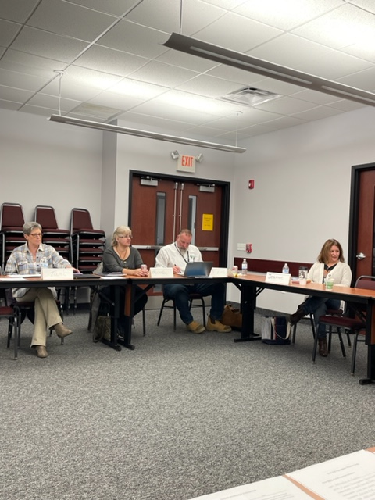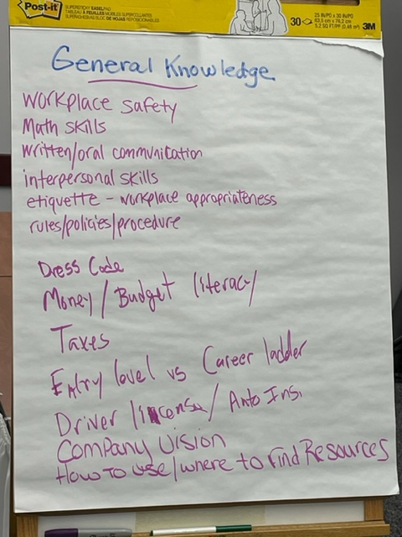

See attached Pennsylvania Diversified Occupations/Co-operative Education Competency Task List for additional tasks added by the local DACUM panel. The Corry Area School District Career & Technical Education Center would like to thank this dedicated panel of professionals for providing their expertise. All input will be analyzed for program improvement.

